**Roger Kleinmann**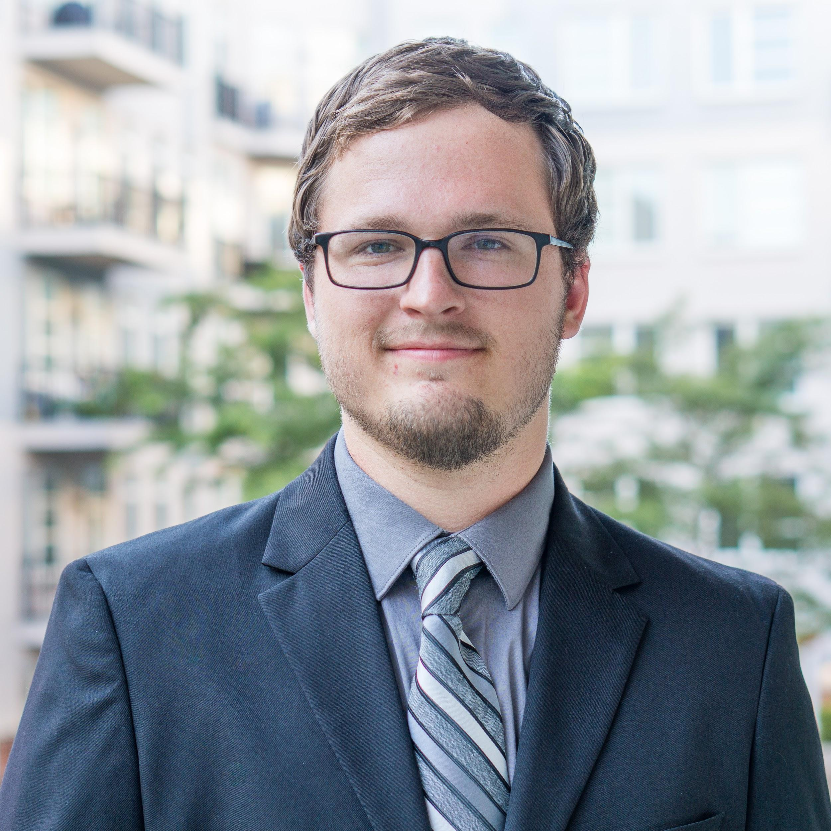

**Undergraduate Major:**

Mechanical Engineering

**Master’s Degree:**

Robotics & Control

**General Biography:**

Roger joined the team with hopes to explore simultaneous localization and mapping (SLAM) through practical application. Both his undergraduate and graduate coursework reflect mechatronics, robotics, and controls, and many of his side projects build on these fields as well. From September 2015 to June 2016, Roger was the project manager of the Stevens Institute of Technology RockSAT C team where, in addition to managing the team, he designed the mechanical subsystem of a 3D printer that was launched into space aboard a NASA rocket. In December 2016 Roger began research in the Wearable Robotics Laboratory at Stevens. Here he is currently working on his thesis on the design and control of both a fully-active and semi-active ankle foot orthosis for rehabilitation. In August 2017 Roger began working with Autonomous Healthcare, a medical device company, developing robotics systems for medicine distribution.

Because of his experience with robot theory and interest in SLAM, Roger hopes to build much of the programming foundation for the team by developing the framework for field mapping and the merging of multiple maps.

Some fun facts about Roger:

* He has been a hobbyist woodworker since the age of 9.
* He entered Stevens as a computer science major.
* He is an active member of Alpha Phi Omega, a National Service Fraternity.

**Kelly Munyan**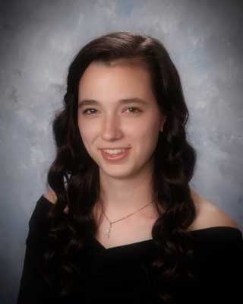

**Undergraduate Major:**

Mechanical Engineering

**Master’s Degree:**

Systems Engineering

**General Biography:**

Kelly is a senior pursuing her bachelor’s degree in mechanical engineering and her master’s degree in systems engineering. She is interested in combining both of her majors together throughout the process of designing a networked multi-robot system. She interned at L3 Technologies in the summer of 2017 and was interested in joining this project to expand her knowledge of programming and robotics. She has worked with many different teams to create a wide variety of robots for her design classes at Stevens. Her favorite project was her Design VI autonomous penguin robot that responded to various stimuli like human touch, light, and food. She loved that the robot was a penguin because the penguin is the mascot for her sorority where she serves as Chapter President. Kelly is very excited to work with the team throughout the year to deliver the first prototype of this multi-year senior design effort to create a network of robots to monitor and inspect the inside of a ship.

Throughout the duration of this project, Kelly would love to be able to work on some of the programming so that she can improve upon her coding skills. She is currently taking a software engineering course to expand her knowledge on Python! She also loves organizing anything and everything, so she will help the team stay organized in documenting, reporting and other aspects of the project. Additionally, Kelly is looking forward to helping create the external environment the robot will use at the Innovation Expo.

Some fun facts about Kelly:

* She is the Chapter President and former Treasurer of her sorority, Theta Phi Alpha.
* She has been playing the flute since third grade and the oboe since eighth grade.
* She graduated with her Associate’s Degree before she graduated from high school.

**Max Panoff**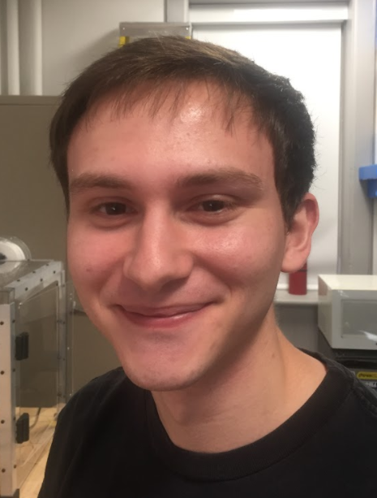

**Undergrad Degree:**

Electrical Engineering

**Undergrad Concentration:**

Robotics & Control

**General Biography:**

Max is finishing up his last year at Stevens pursuing an electrical engineering undergrad. He has significant experience with robotics, having spent multiple summers working on robotics projects at Stevens and taking part of numerous competitions while in high school. He spent the last summer working on a project under Professor Englot where he set up an underwater simultaneous localization and mapping (SLaM) systems using a Doppler Velocity Log (DVL). Max hopes to be able to continue working in this field for the foreseeable future. He is also keen on developing his skills with machine learning and knows this project to be an excellent opportunity to do so.

Max has experience with the system that the team is hoping to use for the project, as well as contacts with people who are researching the field and hopes to be able to utilize his expertise to smooth over and prevent any hiccups during the design.

Some interesting facts about Max:

* He is from Hawaii.
* He has worked as a Teaching Assistant in Design courses at Stevens.
* He has been to the top of the tallest mountain in the world and the highest point in the pacific.

**Christina Maher**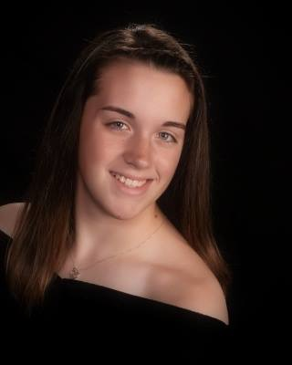

**Undergraduate Major:**

Mechanical Engineering

**Undergraduate Concentration:**

Product Design & Manufacturing

**General Biography:**

Christina is a senior who is interested in a variety of engineering areas, especially product design and manufacturing. She was initially intrigued by this project for its originality as well as the technical applications that would be applied to a multi-robot system, including the simulation and localization mapping. She is also excited to work with the team to develop the best course of action to connect the robots and their information while also creating a base product that can be further developed by future Senior Design teams.

Christina has performed research studies using machine learning and CAD software and is looking forward to using this knowledge to aid in the programming and simulation of this robot system. Additionally, she is interested in the business aspects of the project and hopes to contribute and develop these skills as the year goes on. Apart from the technical aspects of the project, Christina also enjoys art and hopes to apply this creative approach to the project, both while designing as well as throughout the development and troubleshooting phases.

Some fun facts about Christina:

* She has held a human brain.
* She has biked across the Golden Gate Bridge.
* She is an active member of Alpha Phi Omega, a National Service Fraternity.